Page 1 The Stars

The very early universe contained only hydrogen molecules. They clumped together, gravity pulling them into protostars. The increasing pressure raised the temperature enough to produce a plasma in which electrons were ripped away from the atoms, forming an ionized gas of protons; in this plasma energy-generating fusion of protons occurred. The resulting stars are thus giant luminous spheres of plasma. They are grouped in galaxies containing 100-400 billion stars. There are 100-200 billion galaxies in the Universe.
This summary includes an account of how stars are formed, a description of how the various types are classified and some notes on how astronomical distances are determined.

Star formation
The interior of a star is very hot - related to the high pressure due to gravity. All the material is in the form of plasma, superheated matter – so hot that the electrons are ripped away from the atoms, forming an ionized gas, initially of protons. It comprises over 99% of the visible universe.
All the 100 naturally-occurring elements in the Universe have arisen from the starting protons in the plasma. Initially, fusion reactions in the cores of the young stars produced the nuclei of helium, lithium, beryllium and & boron. Other elements, from carbon up to to iron, were then formed by more complex fusion reactions in the cores of older stars. The fusion reactions produce energy in the form of gamma radiation, keeping the temperature and reaction rates high, leading to a net output of energy. This is what we observe in stars – at all wavelengths of the electromagnetic spectrum (gamma rays, X rays, UV, visible, infrared, microwaves, radiowaves).
There are two routes for production of helium nuclei from proton: Proton-Proton fusion and the Carbon/Nitrogen/Oxygen cycle.

Proton-Proton fusion. (Also called the P-P chain). First suggested by Eddington in 1920 from his assumption (correct) that the only way to produce energy in stars must be to convert mass to energy – according to Einstein’s equation.
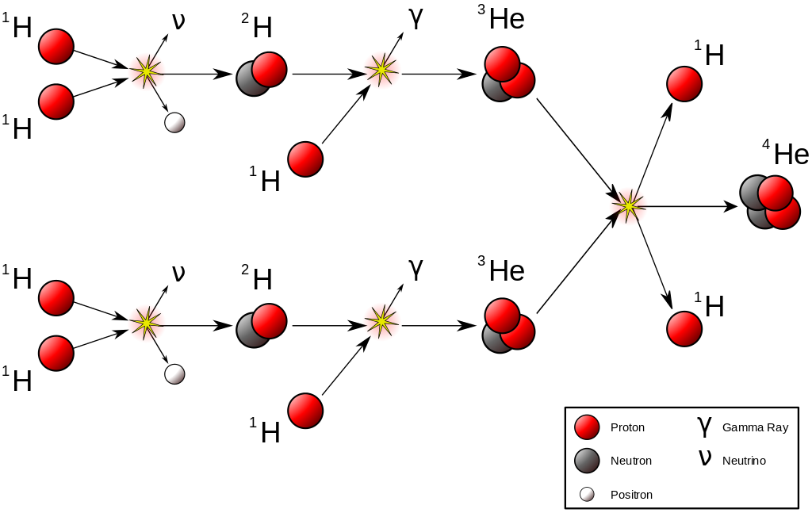 | In this diagram the gold star indicates collisions resulting in a reaction  My summary Starts with 2 protons  P = Proton; N = Neutron  1. P + P PN + positron (annihilated by combination with an electron)  2. P +PN P₂N (He 3) + energy  2 x He3 (P₂N) He 4 (P₂N₂) + 2P

At equilibrium, helium-3 ‘burns’ predominantly by reactions with itself because of its slow reaction with hydrogen, while burning with deuterium is negligible due to the very low deuterium concentration. Once helium-4 builds up, reactions with helium-3 can lead to the production of still-heavier elements, including beryllium-7, beryllium-8, lithium-7, and boron-8, if the temperature is high enough.

Page 2 The carbon/nitrogen/oxygen cycle (CNO cycle).

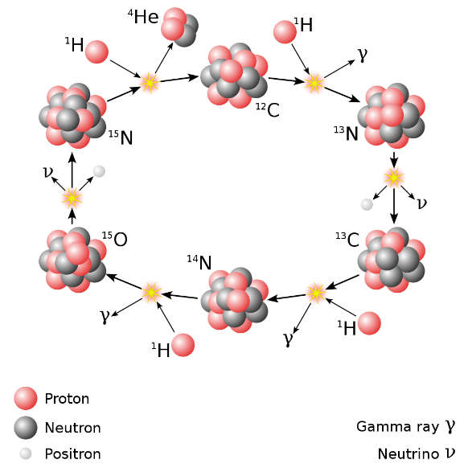 | In this diagram the gold star indicates collision resulting in a reaction  4 protons give a helium nucleus plus energy in the form of gamma radiation. The oxygen and nitrogen are sometimes referred to as catalytic because they do not accumulate.  Some reactions involve addition of a proton. Others involve loss of a positron from a proton, producing a neutron  ¹²C is P₆N₆  ¹³N is P₇N₆  ¹³C is P₆N₇  ¹⁴N is P₇N₇  ¹⁵O is P₈N₇  ¹⁵N is P₇N₈  Helium is P₂N₂

The production of carbon in the Triple alpha fusion. After all the hydrogen has been converted to Helium, (see above) the temperature of the core increases and ‘burning’ of helium to carbon produces the energy.

Carbon is produced in 2 steps from 3 helium nuclei (alpha particles):  2He Be Be + He C + energy  A side reaction can give oxygen plus energy:  C + He O [P₆N₆ + P₂N₂ P₈N₈] | 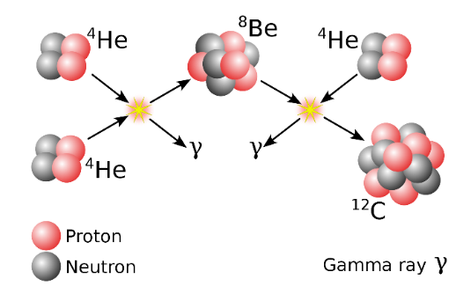

Production of heavy elements. At higher temperatures, as carbon builds up, carbon fusion reactions give rise to magnesium, sodium and neon. Oxygen fusion reactions give sulphur, phosphorous, silicon and magnesium. With further increases of temperature and density, fusion processes produce nuclides (species of atomic nuclei) only up to nickel-56 (which decays later to iron). Fusion of elements with mass numbers (the number of protons plus neutrons) greater than 26 (iron) uses up more energy than is produced by the reaction. Thus, elements heavier than iron cannot be fuel sources in stars. And, likewise, elements heavier than iron are not produced by fusion reaction in stars.
The construction of elements heavier than iron involves neutron capture. A nucleus can capture or fuse with an electrically-neutral neutron as it is not repulsed like the positively charged protons. Each neutron capture produces an isotope, some stable, some unstable, and these decay by emitting a positron and a neutrino to add an extra proton and so make a new element.
The slow capture of neutrons, the s-process, produces about half of the elements beyond iron. The other half are produced by rapid neutron capture, the r-process. The s-process, in the inert carbon core of a star, works as long as the decay time for unstable isotopes is longer than the capture time. Up to the

Page 3

element bismuth (atomic number 83), the s-process works, but above this point the more massive nuclei that can be built from bismuth are unstable.
The second (rapid) process, the r-process, produces the very heavy, neutron rich nuclei. The capture of neutrons happens in such a dense environment that the unstable isotopes do not have time to decay. The high density of neutrons needed is only found during a supernova explosion and, thus, all the heavy elements in the Universe (up to uranium) are produced this way. The supernova explosion also has the side benefit of propelling the new created elements into space to seed molecular clouds which will form new stars, which will start with a more complex elemental content than earlier simpler stars starting only with hydrogen.

Supernovae
Stars greater than 25 solar masses undergo a violent end to their lives. The final 'stable product' of fusion reactions is iron. Since iron does not act as a fuel, energy generation stops, causing the 'outward' pressure to drop and the outer layers of the star to fall onto the core. The infalling layers collapse so fast that they `bounce' off the iron core at close to the speed of light. causing the star to explode as a supernova. The energy released during this explosion is so immense that the star will outshine an entire galaxy for a few days. Supernovae can be seen in nearby galaxies, about one every 100 years.
The violence of the first 15 minutes of a supernova explosion creates huge numbers of free neutrons so that the neutron capture rate of nuclei is so high (the r-process described above) that even unstable nuclei capture new neutrons before they can decay to more stable forms. This creates all of the elements heavier than bismuth 209. This explains why these elements are so rare in the universe, and why the abundance of the heaviest elements (heavier than iron) is a billion times lower than the abundance of hydrogen and helium.

Page 4
The evolution and classification of stars, and the Hertzsprung-Russell Diagram
The colour of a star is related to its temperature (blue / hot; red / cool) and may be expressed as the spectral type. The luminosity of a star is the energy it radiates. This is estimated from its observed brightness and its distance from us. The luminosity can be expressed as the Absolute magnitude. There is also a relationship between mass* and luminosity.
Hertzsprung and Russell, working independently, demonstrated a relationship between the brightness of a star and its colour. The H-R diagram plots luminosity (or absolute magnitude) against the temperature (or spectral type) of stars. Red giant and white dwarf stars follow no pattern, but main sequence stars fall along a line with luminosity increasing with mass. So more massive stars are on the top left and less massive are on the lower right. Each star goes through evolutionary stages determined by its initial mass, its internal structure and how it produces energy. Each stage has a different temperature and luminosity, and so it moves to different regions on the HR diagram as it evolves.
*Mass was determined using Kepler’s laws on nearby binary stars that rotate around each other. The distance between them can be measured trigonometrically and the speed of rotation around each other by the doppler effect on their spectra.

There are three main stages seen on the H-R diagram:
1. The main sequence stretching from the upper left (hot, luminous stars) to the bottom right (cool, faint stars). Stars spend about 90% of their lives here, burning hydrogen into helium in their cores.
2. Red giant and supergiant stars in the region above the main sequence have low surface temperatures and high luminosities and so also have large radii. They enter this evolutionary stage after exhausting the hydrogen in their cores and have started to burn helium and other heavier elements.
3. White dwarf stars are the final evolutionary stage of low to intermediate mass stars, and are in the bottom left of the HR diagram. These stars are very hot but have low luminosities due to their small size.
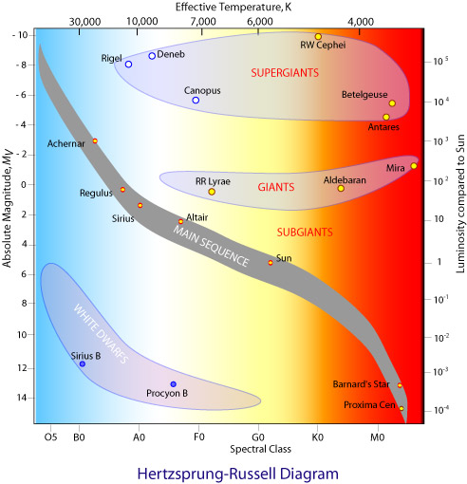

Page 5

Main sequence stars. 90% of stars including our sun. All stars start as Main sequence stars.
The core temperature is hot enough for hydrogen nuclei (protons) to overcome coulombic repulsion and fuse to form helium nuclei (Proton-Proton fusion), a small amount of mass being released as energy in the form of gamma radiation. This burning provides the radiation pressure that supports main sequence stars against further gravitational collapse. If a protostar is less massive than this, fusion cannot be triggered and it becomes a brown dwarf or a "failed" star, emitting energy in the infrared.
In higher mass main sequence stars the CNO cycle (carbon-nitrogen-oxygen) dominates. The overall result is much the same as for the proton-proton chain, four protons are converted into a He-4 nucleus, releasing gamma radiation.
The greater the mass of a main sequence star, the higher its core temperature and the greater the rate of its hydrogen fusion. Higher-mass stars therefore produce more energy and are thus more luminous than lower mass ones and they consume their core hydrogen fuel much faster. Our Sun has sufficient hydrogen in its core to last about 10 billion years (10¹⁰ years) on the main sequence. A five solar-mass star would consume its core hydrogen in about 70 million years whilst an extremely massive star may only last three or four million years.

Red Giants
When a main sequence star exhausts its stock of hydrogen fuel, fusion in the core and outward radiation pressure stops, and inward gravitational attraction causes the helium core to contract, converting gravitational potential energy into thermal energy. The rise in temperature heats up the shell of hydrogen surrounding the core leading to hydrogen fusion, producing more energy than when it was a main sequence star.
The increased radiation pressure causes the outer layers to expand to maintain the pressure gradient. As the gas expands it cools, and the star thus appears redder. Convection transports the energy to the outer layers of the star from the shell-burning region. The densities of the outer layers are extremely low. The star's luminosity eventually increases by a factor of about 1000. producing a red giant. Our Sun will end up as a red giant when it will have a radius 100 times larger than that it has as a main sequence star.
Planetary nebulae produced from Red Giants. These are small emission nebulae consisting of an expanding, glowing shell of ionized gas ejected from red giant stars late in their lives, often are seen as small fuzzy stars. They are relatively short-lived, lasting a few tens of millennia. After all of the red giant's atmosphere has been dissipated, ultraviolet radiation from the exposed hot luminous core, called a planetary nebula nucleus, ionizes the ejected material causing it to appear as a brightly coloured planetary nebula. Planetary nebulae probably play a crucial role in the chemical evolution of galaxies by expelling elements created in the original star into the interstellar medium. Planetary nebulae observed in more distant galaxies, yield useful information about their chemical abundances.

White Dwarfs
Most stars with masses similar to our Sun end their lives as a stellar remnant called a white dwarf.
With their fuel used up there is no outward radiation pressure to withstand gravitational collapse. A white dwarf is composed of carbon and oxygen ions mixed in with a sea of degenerate electrons. It is the degeneracy pressure provided by the electrons that prevents further collapse. This occurs when gravitational pressure is so extreme that quantum mechanical effects are significant.
A white dwarf, with a mass roughly that of the Sun will be packed into a volume not much greater than the Earth. Its heat will be gradually radiated away but it has only a small surface area so it will take tens to hundreds of billions of years to cool down to a black, inert clump of carbon and degenerate electrons but this has not yet happened so all the white dwarfs that have ever formed are still white dwarfs. They are so

Page 6
faint they are hard to detect and we are only able to observe relatively close ones. Nonetheless white dwarfs are thought to comprise about 10% of the stars in our galaxy. Nearby examples are Sirius B and Procyon B, both of which are found in binary systems.

Supergiants and Supernovae
High-mass Supergiants such as Betelgeuse, Deneb, Rigel and Antares are rare and have relatively very short lifespans. They consume all their core hydrogen at prodigious rates so may only remain on the main sequence for millions rather than billions of years. The core contracts due to gravity and heats up, triggering helium fusion to carbon (by the triple-alpha process). This starts gradually and the
temperature of the star drops as its outer layers expand. This balances the increased radius so that the overall luminosity remains essentially constant. Energy liberated from the core raises the temperature of the surrounding hydrogen shell so that it too begins fusing. In time the core helium is used up resulting in further core collapse and gravitational heating. This then triggers carbon fusion to produce sodium, neon and magnesium. As each core fuel is used up, further collapse leads to even higher temperatures that trigger fusion of heavier elements. Through a combination of fusion and photodisintegration a range of heavier nuclei are formed - up to iron for the most massive stars.

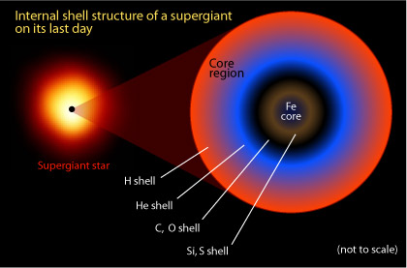 | The core of a supergiant has a dense iron core surrounding by shells of silicon and sulfur, oxygen and carbon, helium and an outer shell of hydrogen

Whilst a massive star (20 x our sun) may spend a few million years on the main sequence, its later helium core-burning phase may be only a few hundred thousand years. The carbon burning phase lasts a few hundred years, neon-burning phase a year, oxygen-burning half a year and the silicon-burning that produces iron takes only a day. In the last stages of a supergiant gamma rays cause photodisintegration of iron, which absorbs energy, causing the outward pressure to drop and the core to rapidly contract further. Protons and electrons produce neutrons (as in a neutron star) and no further collapse occurs.
The surrounding material is still collapsing, and slams into the now solid core and rebounds, forming a massive shockwave. A total of 10⁴⁶ Joules is released in a matter of seconds, 50 × more than the Sun will release in 10 billion years. The massive star is ripped apart, becoming a Type II supernova, reaching about 10⁹ × solar luminosity for a few days before fading over several weeks during which it will outshine the combined luminosity of all the other stars in its galaxy.
During the supernova explosion, a high flux of neutrons is released as iron nuclei are ripped apart. These can be captured by unstable nuclei before the nuclei have had a chance to decay. In this way nuclei of elements such as lead, gold and all the way up to uranium can be synthesised (the r-process).

Neutron stars and black holes
These are what are left over of some of the core material of a star after a supernova ‘explosion’; what happens to this depends on its mass. Gravitational pressure is so extreme that quantum mechanical effects

are significant. The neutrons produced by photodisintegration of iron combine with existing core material to form neutron degenerate matter.
Neutron stars: If the remaining mass of the star is less than about 3 solar masses the collapse of the core is halted by the degeneracy pressure of the neutrons, resulting in a Neutron star with a density about that of atomic nuclei. A thimble-full of this material has a mass of almost 10⁹ tonnes. They range in mass from 1.4 solar masses up to about 3 solar masses. A neutron star is typically about 10 km across. Due to the conservation of angular momentum, a neutron star spins at tens of hundreds of times a second. [The Sun rotates roughly once a month.] Most neutron stars are observed as pulsars, giving pulses of radiation at very regular intervals (from milliseconds to seconds). They have very strong magnetic fields which funnel jets of particles out along the two magnetic poles. These jets are seen as very powerful beams of light sweeping round as the star rotates. When the beam crosses our line-of-sight, we see a pulse.
Black holes: Sometimes, after all other mass-loss processes, the mass of the material left exceeds the limit that even neutron degeneracy pressure can withstand. The material keeps collapsing inwards until all the mass becomes concentrated at a single point, a singularity. It is now a Black hole, an even more exotic object than a neutron star. With all the mass concentrated at a point they have such extremely high gravitational fields that not even light can escape from them once it has crossed a region known as the event horizon. At the event horizon, the escape velocity equals the speed of light. Black holes are therefore hard to observe because they do not emit light at any waveband. Rather than look for a black hole itself, astronomers infer their presence due to their effect on surrounding matter.

Distance measurement relating to stars, galaxies etc

The Parallax method for nearby stars that show parallax (apparent change of position because we have moved)
The angle (A) between the star and a distant reference star is measured with a sextant*, and the changed angle (B) is measured 6 months later. The angle A+B / 2 is called the parallax angle (p in the diagram)
Using trigonometry, the distance to the star is calculated.
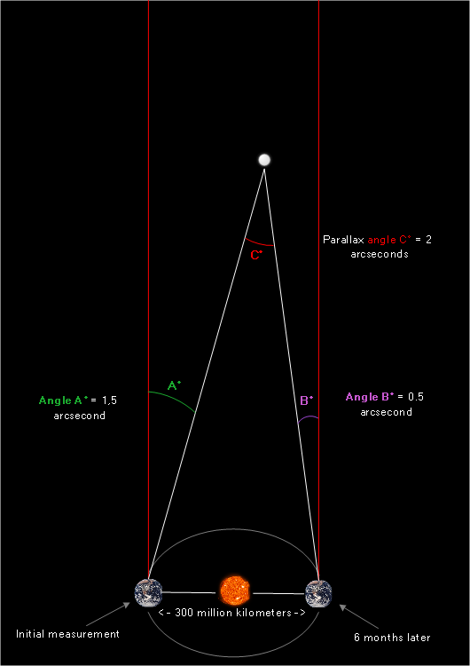 | NB: the red lines are to the reference star. The triangle can be considered an isosceles triangle because the distances are so huge that they ‘are’ the same. 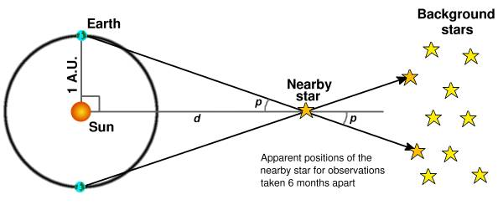  Tangent p = opposite/adjacent, where adjacent is distance to the star (d); opposite is the distance between earth and sun  (s = 186,000,000 miles).  Distance to star d = s x Tan p

Note: most accounts of parallax do not mention what the parallax angle is ‘with’. The parallax method can only be used for stars closer than 300 -400 Light years and most distances are greater. Many of the stars in our galaxy are more than 3000 Light years. *Photographs using space-based telescopes have now been used for a huge numbers of stars.

Page 8
Distance measured from the brightness of the star
A star's spectrum (colour) is a good indication of its Absolute magnitude (luminosity). The relationship between colour and brightness was proven using the several thousand stars close enough to earth to have their distances measured directly. Comparing absolute magnitude and apparent magnitude the distance can be calculated (inverse square law links brightness and distance).
Use of Cepheid variables to measure distance
Classical Cepheids were first described in the constellation Cepheus. They are young, massive, and luminous yellow supergiants which undergo pulsations with very regular periods in the order of days to months. In the early 1900s Henrietta Leavitt studied photographic plates of the Magellanic Clouds (our close companion galaxies only visible from Southern hemisphere). 47 of the Cepheid variables with longer periods were brighter than the shorter-period ones. She inferred that as the stars were in the same distant Magellanic Clouds they were about the same distance from us. So, there is a direct relationship between their period and their intrinsic luminosity. This relationship became invaluable in calculating distances within and beyond our galaxy.

Hubble’s law for distant galaxies
Distances are measured using Cepheid variable stars. The velocities are measured from the Doppler shift - the shifting of spectral lines (initially of hydrogen) to a longer wavelength (the red shift) due to the movement of the galaxy away from us.
Galaxies are receding away from us with a velocity (v) proportional to their distance from us (d): v=H x d.
For example: An absorption line measured at 5000Å in the lab is 5050Å in the spectrum of a particular galaxy. The redshift z = 5050 – 5000 / 5000 = 0.001. z = v / c (speed of light) so v = 3000 km/sec away from us.

Miscellaneous Astronomical Numbers
Light travels at 186,000 miles (300,000 km) per second. A light-year is the distance light travels in one Earth year. One light-year is about 6 trillion miles. 6 x 10 12 miles.

Our Sun is about 93 million miles away = 8.3 Light minutes. The next closest star about 4.3 light-years away. Sirius (dog star) is 8.6 Lyrs.

Stars are all in galaxies. There are 100-200 billion galaxies in the Universe.

Our Milky Way is a typical barred spiral galaxy, containing 100–400 billion stars. Its visible diameter is
100,000–200,000 light-years and it is about 1000 light years thick at the spiral arms (more at the bulge).

The Diameter of the sun is about 1.4 million km; Earth is about 13000 km; Moon is 3,400km
So the diameter of the sun is about 100,000 times that of earth which is about 38 times that of the moon.

The Solar System is about 27,000 light-years from the Galactic Centre, which is a supermassive black hole of about 4 million solar masses. The oldest stars in the Milky Way are nearly as old as the Universe itself.

Page 9
The planets in our solar system vary greatly. Jupiter, for example, is approximately 11 times the diameter of the Earth and Mercury is 2.6 times smaller in diameter. Below is a list of the planet’s diameters from largest to smallest. Pluto is included as further reference point.

Jupiter is the largest planet at 139,822 km in diameter. It is one tenth the diameter of the sun and more than 28.5 times larger in diameter than the smallest planet, Mercury.

Saturn is 116,464 km in diameter, so 9 times bigger than the Earth. This number does not include the rings of the planet as they are considered a separate entity.

Uranus has diameter of 50,724 km, almost 4 times the diameter of Earth and over 10 times the diameter of Mercury.

Neptune, often described as Uranus’s “twin planet” due to their many similar characteristics, is very close in size to Uranus. Neptune is 49,248 km in diameter, making Uranus only 1.3 times larger.

Earth is 12,756 km in diameter. It Is about 2.6 times the diameter of the smallest planet, Mercury. 3.67 times the diameter of the Moon.

Venus (Earth’s “twin planet”) is only slightly smaller than Earth with a diameter of 12,104 km. Venus also has a similar gravitational pull.

Mars, the red planet, has a diameter of only 6,780 km. This makes it 20.5 times smaller in diameter than Jupiter. Mars is about half the diameter of planet Earth, with only about 38% of its surface area.

Mercury, the smallest planet, has a diameter of 4,780 km. This makes Jupiter, the largest planet, almot 30 times bigger than Mercury.

Pluto, now designated as a dwarf planet, has a diameter of 2,400 km. This means that Pluto is about 60 times smaller than Jupiter.

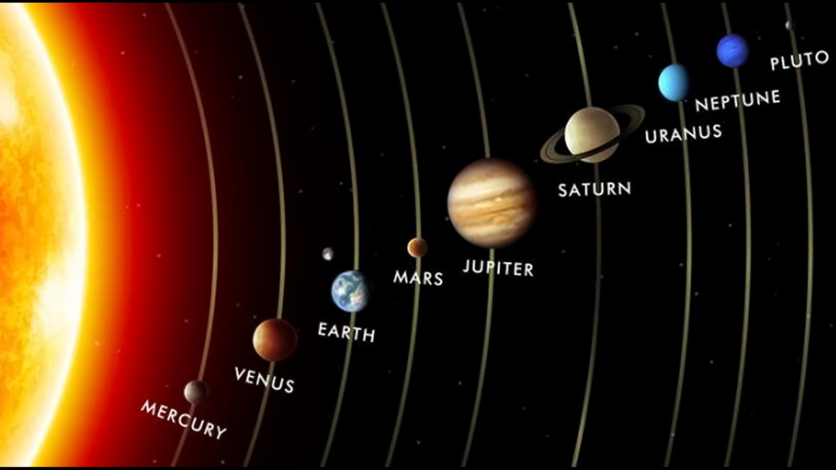

Page 10

Elliptical orbits

Kepler first proposed that the planets move in elliptical, rather than circular, orbits around the sun and Newton explained how this happens. An ellipse has 2 foci with the sun at one focus. However, all discussions, by NASA etc, of the solar system appear to show circular orbits for the planets. By contrast, all sources found using Google start by showing the orbits as very flattened ellipses with the foci very separate. They rarely mention that this is not what the earth’s elliptical orbit looks like.

Question: I wondered how far apart the foci are, and why descriptions and models of the solar system show circular orbits.
The answer: The shortest distance of the Earth to the Sun (y in the diagram) is 147.100 million km, the longest distance (x) is 152.096 million km. This is a tiny difference of about 3%, which is why planetary orbits can be represented for convenience as circles.
Earth's orbital eccentricity (e) quantifies how much the Earth's orbital path deviates from a circle.
Based on Kepler's first law of planetary motion, it can be mathematically described as: e² = 1 - y²/ x²
The present eccentricity of Earth is e ≈ 0.01671.

